Title: Urban Coyotes are more Exploratory and more Frequently Solve Puzzles than Wild Conspecifics
Authors: Sage Raymond¹*, Sarah Benson-Amram², Colleen Cassady St. Clair¹
Affiliations:
¹University of Alberta, Edmonton, Canada.
²Univeristy of British Columbia, Vancouver, Canada.
*Corresponding author. Email: rraymon1@ualberta.ca

Abstract: The capacity for some urban-adapting species to exploit novel resources in urban environments is presumed, but seldom tested, to result from cognitive flexibility. We developed puzzles with small food rewards to assess the problem-solving abilities and related cognitive behaviours of coyotes (Canis latrans), which are one of the most successful and ubiquitous urban adapters in North America. Coyotes at more urbanized sites, both within a city and between a city and natural area, showed greater exploration, greater persistence, and more frequently solved puzzles. Urbanization remained explanatory, even when accounting for intrinsic and environmental factors that can influence cognition and problem-solving. These results suggest that the opportunities and complexities afforded by urban environments can change animal cognition, with implications for human-wildlife coexistence.

Main Text:
Global increases in urbanization create novel environments to which wildlife species that persist in cities must adapt (1). Rapid adaptation to urban environments logically involves behavioural flexibility and associated cognition. Behavioural flexibility refes to the ability to change behaviour in response to changing environmental stimuli (14) and this advantageous trait often appears in urban carnivores (10). Generalist carnivores with greater behavioural flexibility typically forage on a variety of foods types (4) and cities offer high heterogeneity (12, 13) and diverse sources of anthropogenic food. These results are consistent with the cognitive buffer hypothesis, which suggests that increased brain size—a metric of intelligence (8)—buffers individuals against environmental challenges by enabling novel or flexible behavioural responses (9). The development of large brains, in turn, may result from access to abundant, calorie-rich food in urban environments (10), as per the expensive tissue hypothesis (11). Tests of a few urban-adapted generalist carnivores have revealed that urban-living individuals display improved metrics of cognition and intelligence compared to conspecifics living outside of cities (2–6), but other species exhibit no such difference (7).
Behavioural flexibility and cognition can be assessed empirically by testing the problem-solving abilities of animals (10, 16). Solving puzzles typically requires innovation to apply previous knowledge to solve a novel problem (17), and persistence, which is continued effort despite failure to complete a task (18). Both behaviours exhibit cognition, which refers to the ability of an animal to receive, integrate, and act upon information from its environment (ref). Puzzles also require interaction with a novel human object, invoking boldness, which is defined as exploration of unfamiliar situations and objects (19) (20). Greater boldness in urban animals relative to wild-dwelling conspecifics has been observed in canids (19, 21), birds (22, 23), small mammals (24, 25), and reptiles (26–28). Both boldness and resulting habituation to novel circumstances can persist across animal lives (30) and generations (31, 32) suggesting that behavioural flexibility in urban animals may have genetic or epigenetic components (27, 33, 34). Studies are lacking for medium and large urban-adapted carnivores, for whom behavioural responses to novelty may play a critical role in shaping outcomes of human–wildlife coexistence (2).
We aimed to compare the influence of urbanization on problem-solving abilities and related behaviours of wild-living coyotes (Canis latrans)—a ubiquitous and highly successful urban-adapted mesocarnivore that is increasingly prevalent and prone to conflict with people in cities across North America (35–37). We did so by deploying puzzles made of mostly of wood vs. mostly of plastic and extracting behavioural metrics for persistence, exploration, fearfulness, and behavioural complexity from resulting videos. We related these behaviours to urbanization and a suite of environmental and intrinsic characteristics associated with events. We completed these analyses at two scales of urban development by comparing behaviours (1). between an urban environment and a nearby protected, natural area and (2) along a continuous gradient or urbanization within the city. If urban coyotes encounter more anthropogenic resources that reward boldness in urban areas, we predicted greater exploration and persistence and, less fearfulness compared to wild conspecifics, especially for the more anthropogenic puzzles. If urban coyotes frequently access calorie-rich food rewards that favour greater cognitive flexibility, we predicted greater behavioural diversity and more frequent solutions to the puzzles.
Results
Between January and April in 2024 and 2025, we recorded a total of 1761 events of coyotes at puzzle assays, most of which occurred in the city (n = 1499, 85.1%; Movies 1-5). In 1156 events, the animal was oriented to the puzzle so the event was retained for subsequent behavioural analysis. Coyotes investigated puzzles in 486 events (42.0%), 458 of which occurred in the city (94.2%), and investigations lasted for 0.25 to 248.03 seconds. Coyotes contacted puzzles in 231 events (20.0%), 220 of which occurred in the city (95.2%) and contact occurred for 0.07 to 144.57 seconds. Among events in which contact occurred, the number of behaviours exhibited ranged from 1 to 5 (x = 2.06, SD = 1.19). Coyotes exhibited fearfulness by fleeing with an escape gait 146 times (12.6% of events; 33.1% of events in wild). In total, coyotes solved puzzles in 48 events (4.2%), all of which occurred in the city. Sex was apparent in 1028 events (88.9%), and animals were visibly diseased in 376 events (32.5%). Most events occurred in darkness (n = 793, 68.6%). Events with a single focal animal were most common (n = 922, 79.8%), but group size ranged between 1 and 4. Mean daily temperature was -4.7°C (SD = 8.5) and ranged between -26.8°C and 9.9°C. Events involved wooden puzzles (n = 592; 51.2%) and plastic puzzles (n = 564; 48.8%) at similar rates.
Urbanization strongly influenced problem-solving and related behaviours (Fig. 2). Univariate models revealed that, relative to events occurring at wild sites, events in the city were characterised by four times greater odds of both investigation and contact, a 9.4% longer investigation duration, and a 25% longer contact duration (Table 1). City coyotes used 7.6% more behaviours and were 82% less likely to demonstrate an escape gait indicative of fear. Models containing the behavioural metrics of exploration, persistence, fearfulness, and problem solving, but not behavioural complexity imporoved model performance relative to a null model. R² values revealed that, for all models, much of the explanatory power could be attributed to urbanization rather than site ID.
Similar patterns occurred within the city along a continuous urbanization gradient; for a 10% increase in urbanization, odds of investigation and contact increased by 11.7% and 3.1% respectively, and investigation and contact duration increased by 1% and 4% respectively. A 10% increase in urbanization increased the number of behaviours exhibited by 4%. Unlike the categorical comparison between city and wild sites, odds of an escape gait increased by 6% per 10% increase in urbanization. Finally, a 10% increase in urbanization was associated with 25% greater odds of a puzzle being solved. Among these, only models for behavioural complexity and solves improved model performance relative to a null model. Model explanatory power was low for investigation, contact duration, and behavioural complexity. For escape gait and solves, much of the explanatory power could be attributed to site ID (Table 1). We observed the same pattern at the site scale (table S1; figure S1).
Intrinsic variables of sex and health and environmental event attributes of temperature, puzzle type, daylight, and date frequently failed to explain variation in outcome variables related to problem solving, though some patterns emerged (Table 2; table S2; figure S2). Odds of investigation increased when the puzzle was wooden (51%) and when the focal animal was male (9.4%), but predictors of duration had confidence intervals that considerably overlapped 0. Contact occurred more frequently when animals were diseased (99%), during the second year of study (68%), at wood puzzles (95%), and during the day (32%); contact duration was also 25% longer during the day. For behavioural complexity, no predictors improved model performance sufficiently for retention. Odds of departure using an escape gait decreased by 22% for each additional animal in the group. Odds of a solve increased by 12% when the focal coyote was female, though confidence intervals extensively overlapped zero. For these models of intrinsic and environmental variables, only the contact duration model improved model performance relative to a null model. For escape gait and solve models, site ID explained much of the variation (Table 2).
When we included both urbanization metrics and the top predictors related to intrinsic and environmental event characteristics in a set of candidate models, urbanization occurred in the top model for all outcome variables (Table 3; Fig. 3; Table S3). The inclusion of interaction terms and dispersion formulas failed to improve model performance for any variable. When we included individual ID as a second random effect in all models, we attained results that were categorically the same, but with weaker statistical power and some convergence problems given added model complexity (Tables S4 – S6).
Discussion
Accelerating urbanization is rapidly transforming natural landscapes, creating novel and complex ecosystems (1) to which some species successfully adapt while others do not (38). Such adaptation often requires behavioural flexibility supported by cognition, which enables organisms to navigate novel challenges like human presence (39), vehicle traffic (40), and limited refugia (41), while taking advantage of opportunities like reduced predation pressure (37) and access to rich anthropogenic food sources (15, 42). We showed that coyotes, a ubiquitous and successful north American mesocarnivore, exhibited greater behavioural flexibility with increasing urbanization and that urban animals more often solved a novel problem to gain food resources. Our results support the idea that behavioural and cognitive adjustments are central to the success of urban-adapting wildlife.
Urbanization was the strongest predictor of all behavioural outcomes that we measured. Starting with investigation, which is related to both boldness and curiosity, greater boldness at more urbanized sites aligns with patterns observed in other taxa, including coyotes (19), red foxes (Vulpes vulpes) (21), birds (22, 23), small mammals (24, 25), and reptiles (26–28), in which urban individuals exhibit increased boldness. Corresondingly, fearfulness expressed by use of escape gaits was higher in the wild setting, suggesting greater neophobia in less urban environments. We were surprised to see an increase in the use of escape gaits at the highest levels of urbanization, but some of these videos were suggestive of play behaviour, which often includes escape gaits. Others suggest that boldness may be most adaptive in moderately urbanized areas, such as suburbs (2). Persistence was also greater in urban areas, which is a frequent correlate of problem-solving (20, 43–45). Urbanization had a non-significant, positive effect on behavioural complexity, suggesting that the underlying motor repertoire was similar regardless of urbanization. This pattern supports the idea that improved problem solving in cities is not due to enhanced motor capacity, but rather to cognitive traits such as boldness, persistence, or exploratory tendencies (21). Finally, actual problem-solving success was highest in urban environments, consistent with the cognitive buffer hypothesis (8) that animals in more complex and variable environments require and exhibit greater cognitive and behavioural flexibility. Previous studies with captive coyotes have documented limited evidence of problem-solving, apparently due to their strong neophobia (18, 46–49).
Models comparing behaviour between urban and wild sites explained more variance than those comparing sites within the city, suggesting that behavioural differences between urban and wild settings were more predictable than those within a city. Consistent with existing evidence of heterogeneity within cities and impacts on animal behaviour (13), trends within the city generally aligned with our predictions about urban heterogeneity, but were statistically weaker and more variable. Several factors could explain this pattern. First, the urban metric we used (i.e., percent anthropogenic cover) was structural, which may have failed to capture to most ecologically relevant predictors of animal behaviour (50). For example, we imagine that access to anthropogenic food and consequent food conditioning (51) greatly increase boldness towards unknown anthropogenic objects, such as these puzzles. Such factors are highly localized and difficult to measure consistently across sites (52). Second, coyote home ranges are typically stable over time (53), and coyotes demonstrate both vertical (32) and horizontal (18) learning, suggesting that local social or ‘cultural’ context could strongly influence response (54). Finally, at the highest levels of urbanization, behavioural patterns may shift due to resource availability. Analysis of home range sizes suggests that resource availability for coyotes, which likely includes anthropogenic subsidies, is highest in suburbs, rather than extremely urbanized sites (36), perhaps predicting higher boldness at such sites as well.
Environmental and intrinsic event characteristics had some limited influence on behavioural outcomes, but effect sizes were small and frequently statistically non-significant, especially when compared to urbanization metrics. Wooden puzzles were more likely to be investigated and contacted, perhaps because they lacked strong anthropogenic cues and were perceived as less threatening by neophobic animals (46, 48, 49). Diseased individuals were more likely to contact puzzles, which could reflect the increased risk-taking that occurs in physiologically stressed individuals (55), or the known relationship among disease, anthropogenic food consumption, and boldness (56). Odds of contact also increased during daylight hours, perhaps because shyer individuals are more nocturnal (40). Contact rates increased in the second year of the study, perhaps due to learned familiarity with puzzles. Fear responses were less likely with increasing group size, which could reveal increased comfort from increased vigilance for predators (57). Though many studies have not found an effect of sex on problem solving (44), we found that males were somewhat more likely to investigate puzzles, consistent with literature suggesting greater boldness in males (58), but females were marginally more likely to solve puzzles.
Urban wildlife is an increasing component of the novel and complex urban ecosystems that humans are creating (1). This raises important questions about how these environments are influencing animals, including in behavioural and cognitive realms. Our findings, along with those of others (2), suggest that urban systems impose distinct selective pressures that can foster traits like boldness, exploration, innovation, and persistence—traits that may, over time, contribute to long-term evolutionary change (2). Behavioural flexibility and adaptability matter for several reasons. First, such flexibility creates opportunities for effective, non-lethal management in the context of human-wildlife conflict. Interventions such as aversive conditioning leverage behavioural flexibility and the capacity for animal learning to discourage boldness and encourage coexistence behaviours (59). More broadly, in a world that is changing rapidly courtesy of expanding urbanization and climate change, evidence of rapid adaptation to novel challenges underscores the capacity of some species to flexibly navigate, persist, and thrive within human-altered landscapes

Our study clearly demonstrated with multiple behavioural metrics that behavioural flexibility and concomitant resource acquisition were greater in urban coyotes relative to animals living in a nearby natural area and these metrics increased within a city along an urban gradient. These differences are unlikely to stem from genetic variation because coyotes range widely in both rural areas (ref) and urban ones (refs). Instead, they suggest that behaviour flexibility for which coyotes are renowned (ref) supports the ability of individuals to explore and adapt to novel resources in cities. The intrinsic behavioural flexibility of coyotes may be enhanced by anthropogenic food, favouring further increases in expensive brain tissues (ref), which in turn favour more cognitive buffer (ref) and greater capacity to adapt to changing urban environments. Such a positive feedback loop may contribute to the increasing prevalence of coyotes in urban areas throughout North America (ref) and their recent self-introduction to South America (ref). Comparative studies of the cognitive characteristics of urban-adapting and urban-avoiding species could reveal information pertinent to human-wildlife coexistence in an increasingly urban world.
References and Notes
1. H. Lowry, A. Lill, B. B. M. Wong, Behavioural responses of wildlife to urban environments. Biological Reviews 88, 537–549 (2013).
2. C. J. Schell, L. A. Stanton, J. K. Young, L. M. Angeloni, J. E. Lambert, S. W. Breck, M. H. Murray, The evolutionary consequences of human-wildlife conflict in cities. Evolutionary Applications 14, 178–197 (2021).
3. L. Stanton, E. Davis, S. Johnson, A. Gilbert, S. Benson-Amram, Adaptation of the Aesop’s Fable paradigm for use with raccoons (Procyon lotor): considerations for future application in non-avian and non-primate species. Animal Cognition 20, 1147–1152 (2017).
4. L. A. Stanton, E. S. Bridge, J. Huizinga, S. Benson-Amram, Environmental, individual and social traits of free-ranging raccoons influence performance in cognitive testing. Journal of Experimental Biology 225, jeb243726 (2022).
5. L. P. Barrett, L. A. Stanton, S. Benson-Amram, The cognition of “nuisance” species. Animal Behaviour 147, 167–177 (2019).
6. S. E. Daniels, R. E. Fanelli, A. Gilbert, S. Benson-Amram, Behavioral flexibility of a generalist carnivore. Animal Cognition 22, 387–396 (2019).
7. E. Vincze, B. Kovács, Urbanization’s effects on problem solving abilities: A meta-analysis. Frontiers in Ecology and Evolution 10, 834436 (2022).
8. S. Benson-Amram, B. Dantzer, G. Stricker, E. M. Swanson, K. E. Holekamp, Brain size predicts problem-solving ability in mammalian carnivores. Proceedings of the National Academy of Sciences of the United States of America 113, 2532–2537 (2016).
9. D. Sol, Revisiting the cognitive buffer hypothesis for the evolution of large brains. Biology Letters 5, 130–133 (2009).
10. S. Benson-Amram, H. J. Griebling, C. M. Sluka, The current state of carnivore cognition. Animal Cognition 26, 37–58 (2023).
11. K. Isler, C. P. van Schaik, The expensive brain: a framework for explaining evolutionary changes in brain size. Journal of human evolution 57, 392–400 (2009).
12. S. T. A. Pickett, M. L. Cadenasso, E. J. Rosi-Marshall, K. T. Belt, P. M. Groffman, J. M. Grove, E. G. Irwin, S. S. Kaushal, S. L. LaDeau, C. H. Nilon, C. M. Swan, P. S. Warren, Dynamic heterogeneity: a framework to promote ecological integration and hypothesis generation in urban systems. Urban Ecosystems 20, 1–14 (2017).
13. T. Caspi, M. G. Serrano, S. L. Vanderzwan, J. Kessler, C. J. Schell, B. N. Sacks, Impervious surface cover and number of restaurants shape diet variation in an urban carnivore. Ecosphere 16, e70152 (2025).
14. S. E. G. Lea, P. K. Y. Chow, L. A. Leaver, I. P. L. McLaren, Behavioral flexibility: A review, a model, and some exploratory tests. Learning & Behavior 48, 173–187 (2020).
15. S. Raymond, D. K. Steckler, M. A. Seguin, C. C. St. Clair, Coyote scat in cities increases risk of human exposure to an emerging zoonotic disease in North America. FRONTIERS IN CONSERVATION SCIENCE 4, 1294693 (2024).
16. J.-N. Audet, L. Lefebvre, What’s flexible in behavioral flexibility? Behavioral Ecology 28, 943–947 (2017).
17. S. M. Reader, J. Morand-Ferron, E. Flynn, Animal and human innovation: novel problems and novel solutions. Philosophical Transactions of the Royal Society B-Biological Sciences 371, 20150182 (2016).
18. J. K. Young, L. Touzot, S. P. Brummer, Persistence and conspecific observations improve problem-solving abilities of coyotes. Plos One 14, e0218778 (2019).
19. S. W. Breck, S. A. Poessel, P. Mahoney, J. K. Young, The intrepid urban coyote: a comparison of bold and exploratory behavior in coyotes from urban and rural environments. Sci Rep 9, 2104 (2019).
20. S. Benson-Amram, M. L. Weldele, K. E. Holekamp, A comparison of innovative problem-solving abilities between wild and captive spotted hyaenas, Crocuta crocuta. Animal Behaviour 85, 349–356 (2013).
21. F. B. Morton, M. Gartner, E.-M. Norrie, Y. Haddou, C. D. Soulsbury, K. A. Adaway, Urban foxes are bolder but not more innovative than their rural conspecifics. Animal Behaviour 203, 101–113 (2023).
22. J. Evans, K. Boudreau, J. Hyman, Behavioural syndromes in urban and rural populations of song sparrows. Ethology 116, 588–595 (2010).
23. J. W. Atwell, G. C. Cardoso, D. J. Whittaker, S. Campbell-Nelson, K. W. Robertson, E. D. Ketterson, Boldness behavior and stress physiology in a novel urban environment suggest rapid correlated evolutionary adaptation. Behavioral Ecology 23, 960–969 (2012).
24. V. Mazza, M. Dammhahn, E. Lösche, J. A. Eccard, Small mammals in the big city: Behavioural adjustments of non-commensal rodents to urban environments. Global Change Biology 26, 6326–6337 (2020).
25. M. Dammhahn, V. Mazza, A. Schirmer, C. Göttsche, J. A. Eccard, Of city and village mice: behavioural adjustments of striped field mice to urban environments. Scientific Reports 10, 13056 (2020).
26. O. Lapiedra, Z. Chejanovski, J. J. Kolbe, Urbanization and biological invasion shape animal personalities. Global Change Biology 23, 592–603 (2017).
27. J. Baxter-Gilbert, J. L. Riley, M. J. Whiting, Bold New World: urbanization promotes an innate behavioral trait in a lizard. Behavioral Ecology and Sociobiology 73, 105 (2019).
28. S. Blanchett, A. Turcotte, G. Blouin-Demers, The impact of urbanization on painted turtle (Chrysemys picta) behaviour. Ethology 130, e13467 (2024).
29. A. Sih, J. Cote, M. Evans, S. Fogarty, J. Pruitt, Ecological implications of behavioural syndromes. Ecology letters 15, 278–289 (2012).
30. K. K. Y. Wat, P. B. Banks, C. McArthur, Linking animal personality to problem-solving performance in urban common brushtail possums. Animal Behaviour 162, 35–45 (2020).
31. A. T. Morehouse, T. A. Graves, N. Mikle, M. S. Boyce, Nature vs. Nurture: Evidence for Social Learning of Conflict Behaviour in Grizzly Bears. Plos One 11, e0165425 (2016).
32. C. J. Schell, J. K. Young, E. V. Lonsdorf, R. M. Santymire, J. M. Mateo, Parental habituation to human disturbance over time reduces fear of humans in coyote offspring. Ecol. Evol. 8, 12965–12980 (2018).
33. J. C. Müller, J. Partecke, B. J. Hatchwell, K. J. Gaston, K. L. Evans, Candidate gene polymorphisms for behavioural adaptations during urbanization in blackbirds. Molecular ecology 22, 3629–3637 (2013).
34. A. C. Miranda, H. Schielzeth, T. Sonntag, J. Partecke, Urbanization and its effects on personality traits: a result of microevolution or phenotypic plasticity? Global change biology 19, 2634–2644 (2013).
35. R. B. Blair, Land use and avian species diversity along an urban gradient. ECOLOGICAL APPLICATIONS 6, 506–519 (1996).
36. S. D. Gehrt, J. L. Brown, C. Anchor, Is the urban coyote a misanthropic synanthrope? The case from Chicago. Cities and the Environment (CATE) 4, 3 (2011).
37. M. E. Gompper, Top carnivores in the suburbs? Ecological and conservation issues raised by colonization of north-eastern North America by coyotes. Bioscience 52, 185–190 (2002).
38. S. Kark, A. Iwaniuk, A. Schalimtzek, E. Banker, Living in the city: can anyone become an “urban exploiter”? Journal of Biogeography 34, 638–651 (2007).
39. K. M. Gaynor, C. E. Hojnowski, N. H. Carter, J. S. Brashares, The influence of human disturbance on wildlife nocturnality. Science 360, 1232-+ (2018).
40. Murray, C. C. St. Clair, Individual flexibility in nocturnal activity reduces risk of road mortality for an urban carnivore. Behav. Ecol. 26, 1520–1527 (2015).
41. S. Raymond, C. C. St Clair, Urban coyotes select cryptic den sites near human development where conflict rates increase. JOURNAL OF WILDLIFE MANAGEMENT 87 (2023).
42. S. Sugden, M. Murray, M. A. Edwards, C. C. St. Clair, Inter-population differences in coyote diet and niche width along an urban–suburban–rural gradient. Journal of Urban Ecology 7, 1–12 (2021).
43. A. S. Griffin, D. Guez, Innovation and problem solving: a review of common mechanisms. Behavioural Processes 109, 121–134 (2014).
44. S. Benson-Amram, K. E. Holekamp, Innovative problem solving by wild spotted hyenas. Proceedings of the Royal Society B: Biological Sciences 279, 4087–4095 (2012).
45. L. Johnson-Ulrich, Z. Johnson-Ulrich, K. Holekamp, Proactive behavior, but not inhibitory control, predicts repeated innovation by spotted hyenas tested with a multi-access box. Animal Cognition 21, 379–392 (2018).
46. L. A. Stanton, E. S. Bridge, J. Huizinga, S. R. Johnson, J. K. Young, S. Benson-Amram, Variation in reversal learning by three generalist mesocarnivores. Animal Cognition 24, 555–568 (2021).
47. A. C. Garcia, M. A. Parsons, J. K. Young, Effects of early-life experience on innovation and problem-solving in captive coyotes. Behavioral Ecology and Sociobiology 76, 141 (2022).
48. A. E. Mettler, J. A. Shivik, Dominance and neophobia in coyote (Canis latrans) breeding pairs. Applied Animal Behaviour Science 102, 85–94 (2007).
49. P. A. Darrow, J. A. Shivik, Bold, shy, and persistent: variable coyote response to light and sound stimuli. Applied Animal Behaviour Science 116, 82–87 (2009).
50. R. J. Moll, J. D. Cepek, P. D. Lorch, P. M. Dennis, E. Tans, T. Robison, J. J. Millspaugh, R. A. Montgomery, What does urbanization actually mean? A framework for urban metrics in wildlife research. Journal of Applied Ecology 56, 1289–1300 (2019).
51. J. B. Hopkins, S. Herrero, R. T. Shideler, K. A. Gunther, C. C. Schwartz, S. T. Kalinowski, A proposed lexicon of terms and concepts for human-bear management in North America. Ursus 21, 154–168 (2010).
52. S. Raymond, C. C. St Clair, Coyotes access diverse anthropogenic attractants at the ecotone between natural and residential urban areas. URBAN ECOSYSTEMS 26, 1589–1605 (2023).
53. A. M. Kitchen, E. M. Gese, E. R. Schauster, Long-term spatial stability of coyote (Canis latrans) home ranges in southeastern Colorado. Canadian Journal of Zoology 78, 458–464 (2000).
54. A. Whiten, J. Goodall, W. C. McGrew, T. Nishida, V. Reynolds, Y. Sugiyama, C. E. Tutin, R. W. Wrangham, C. Boesch, Cultures in chimpanzees. Nature 399, 682–685 (1999).
55. J. S. Gutiérrez, T. Catry, M. Espinosa-Colín, J. A. Masero, J. P. Granadeiro, Heat stress increases risk taking in foraging shorebirds. Functional Ecology 37, 1005–1019 (2023).
56. M. Murray, A. Cembrowski, A. D. M. Latham, V. M. Lukasik, S. Pruss, C. C. St. Clair, Greater consumption of protein-poor anthropogenic food by urban relative to rural coyotes increases diet breadth and potential for human-wildlife conflict. Ecography 38, 1235–1242 (2015).
57. A. S. Griffin, D. Guez, Innovative problem solving in nonhuman animals: the effects of group size revisited. Behavioral Ecology 26, 722–734 (2015).
58. B. R. Smith, D. T. Blumstein, Fitness consequences of personality: a meta-analysis. Behavioral Ecology 19, 448–455 (2008).
59. R. Found, C. C. St Clair, Personality influences wildlife responses to aversive conditioning. Journal of Wildlife Management 82, 747–755 (2018).

Acknowledgments: We thank Darcy Visscher for sharing equipment used for this study, Erick Lundgren for input on our statistical approach and execution, and Sam Kaviar for assistance designing assays. We thank Elk Island National Park staff for supporting this work. This work was approved by the University of Alberta Animal Care Committee (AUP00003950) and Parks Canada (EINP-2023-45676).
Funding:
Alberta Conservation Association Biodiversity Grant (SR)
Faculty of Science Research Fellowship, University of Alberta (CCSC)
Natural Sciences and Engineering Research Council of Canada Discovery Grant 2023-04892 (CCSC)
Natural Sciences and Engineering Research Council of Canada—Canada Graduate Scholarship-Doctoral. (SR)
President’s Doctoral Prize of Distinction, University of Alberta (SR)
Author contributions:
Conceptualization: SR, SBA, CCSC
Methodology: SR, SBA, CCSC
Investigation: SR
Visualization: SR
Funding acquisition: SR, CCSC
Project administration: SR, SBA, CCSC
Supervision: SBA, CCSC
Writing – original draft: SR
Writing – review & editing: SR, SBA, CCSC
Competing interests: Authors declare that they have no competing interests.
Data and materials availability: All data, code, and materials used in the analysis must be available in some form to any researcher for purposes of reproducing or extending the analysis. Include a note explaining any restrictions on materials, such as materials transfer agreements (MTAs). Note accession numbers to any data relating to the paper and deposited in a public database; include a brief description of the data set or model with the number. If all data are in the paper and supplementary materials, include the sentence “All data are available in the main text or the supplementary materials.”
Supplementary Materials
Materials and Methods
Figs. S1 to S2
Tables S1 to S6
References (##–##)
Movies S1 to S5
DATA

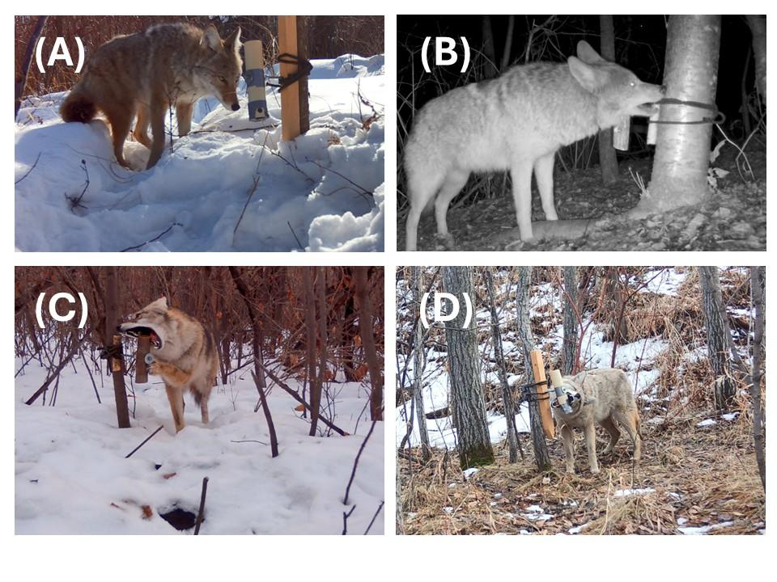
Fig. 1. Wild-living coyotes used various behaviours to solve puzzles. (A) We defined investigation as coyotes being oriented towards and within one head length of puzzles. Examples of contact behaviours included pulling at the bungee that attached the puzzle to the tree (B), biting the top of the puzzle (C), spinning the puzzle with a paw (C) and biting the bottom of the puzzle (D).

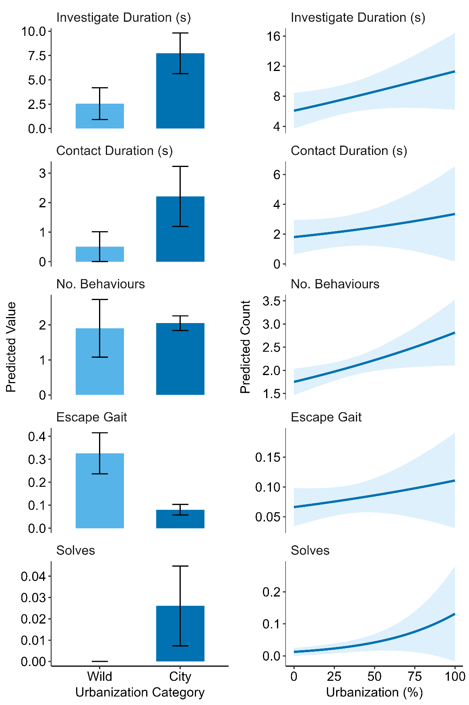
Fig. 2. Urbanization increases problem-solving and related behaviours in wild-living coyotes. Predicted counts for a suite of behaviours related to problem solving in wild-living coyotes at different levels of urbanization, 2024 - 2025. Panels on the left show the predicted counts for wild sites and city sites, and panels on the right show predictions for sites within the city along an urbanization gradient.
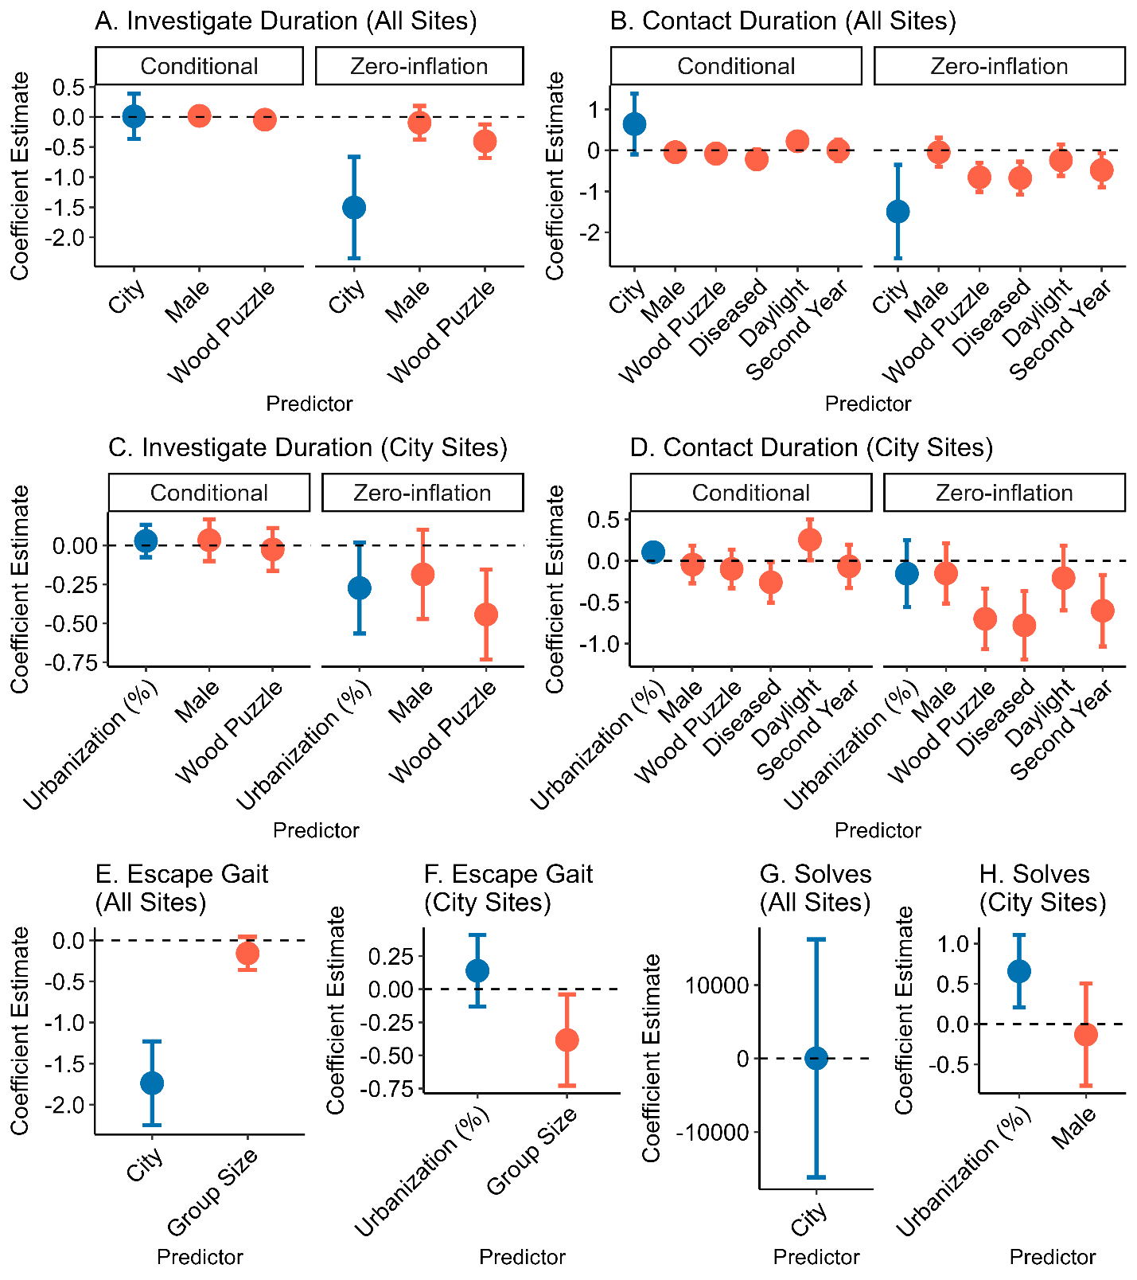
Fig. 3. Urbanization metrics had the strongest influence on problem-solving and related behaviours, even when other environmental and intrinsic factors were considered. Standardized coefficient estimates for top models explaining variation in problem solving and constituent behaviours during events in wild-living coyotes, 2024-2025. Coefficients related to urbanization are in blue, and those related to intrinsic and environmental event characteristics are in red. The zero inflation components indicate the chances of a structural zero (no record of the behavior) occurring.

Table 1. Influence of urbanization on problem solving and related behaviours. Results for models explaining variation in problem solving and constituent behaviours during events at sites with various levels of urbanization in wild-living coyotes, 2024-2025. Metrics reported include sample size (N), Akaike Information Criterion (AIC), beta coefficient (B), P-value (P), effect size (ES), upper and lower confidence intervals (CI) for beta coefficients and effect sizes, marginal (M) and conditional (C) R2, and the P-value for a likelihood ratio test comparing the focal univariate model to a null (LRT).
Predictor | Outcome | N | AIC | B | P | Low CI | Upp CI | Effect Size | Low CI | Upp CI | M. R² | C R² | LRT
City (vs. Wild) | Investigate Duration | 1156 | 4986.3 | 0.090 | 0.606 | -0.251 | 0.431 | 1.094 | 0.778 | 1.538 | 0.000 | 0.001 | 0.006
City (vs. Wild) | Zero Inflation | 1156 | 4986.3 | -1.419 | <0.001 | -2.118 | -0.720 | 0.248 | 0.120 | 0.487 | 0.000 | 0.001 | 0.006
City (vs. Wild) | Contact Duration | 1156 | 2523.8 | 0.224 | 0.401 | -0.300 | 0.749 | 1.252 | 0.741 | 2.114 | 0.000 | 0.001 | 0.001
City (vs. Wild) | Zero Inflation | 1156 | 2523.8 | -1.396 | 0.003 | -2.304 | -0.487 | 0.248 | 0.100 | 0.614 | 0.000 | 0.001 | 0.001
City (vs. Wild) | No. Behaviours | 231 | 733.0 | 0.074 | 0.745 | -0.369 | 0.517 | 1.076 | 0.691 | 1.676 | 0.001 | 0.012 | 0.742
City (vs. Wild) | Escape Gait | 1156 | 820.0 | -1.711 | <0.001 | -2.217 | -1.205 | 0.181 | 0.109 | 0.300 | 0.092 | 0.133 | <0.001
City (vs. Wild) | Solves | 1156 | 358.7 | 20.014 | 0.998 | NA | NA | NA | NA | NA | 0.911 | 0.937 | 0.003
Urbanization (Within City) | Investigate Duration | 996 | 4638.8 | 0.015 | 0.783 | -0.089 | 0.119 | 1.001 | 0.996 | 1.005 | 0.000 | 0.001 | 0.284
Urbanization (Within City) | Zero Inflation | 996 | 4638.8 | -0.046 | 0.736 | -0.312 | 0.220 | 0.989 | 0.978 | 1.000 | 0.000 | 0.001 | 0.284
Urbanization (Within City) | Contact Duration | 996 | 2380.0 | 0.088 | 0.108 | -0.019 | 0.196 | 1.004 | 0.999 | 1.008 | 0.000 | 0.001 | 0.150
Urbanization (Within City) | Zero Inflation | 996 | 2380.0 | -0.131 | 0.453 | -0.473 | 0.211 | 0.997 | 0.982 | 1.012 | 0.000 | 0.001 | 0.150
Urbanization (Within City) | No. Behaviours | 220 | 695.9 | 0.114 | 0.012 | 0.026 | 0.203 | 1.004 | 1.001 | 1.007 | NA | NA | 0.015
Urbanization (Within City) | Escape Gait | 996 | 614.9 | 0.136 | 0.335 | -0.141 | 0.413 | 1.006 | 0.994 | 1.017 | 0.005 | 0.056 | 0.346
Urbanization (Within City) | Solves | 996 | 353.5 | 0.596 | 0.011 | 0.135 | 1.058 | 1.025 | 1.006 | 1.045 | 0.081 | 0.255 | 0.022
Table 2. Influence of environmental and intrinsic factors on problem solving and related behaviours. Results for top models explaining variation in problem solving and constituent behaviours during events using intrinsic and extrinsic event factors in wild-living coyotes, 2024-2025. Metrics reported include sample size (N), Akaike Information Criterion (AIC), beta coefficient (B), P-value (P), effect size, upper and lower confidence intervals (CI) for beta coefficients and rate ratios and the P-value for a likelihood ratio test comparing the focal univariate model to a null (LRT).
Outcome | Predictor | N | AIC | B | P | Low CI | Upp CI | Effect Size | Low CI | Upp CI | M. R² | C. R² | LRT
Investigate Duration | Male | 1028 | 4586.3 | 0.019 | 0.773 | -0.112 | 0.151 | 1.020 | 0.894 | 1.163 | 0.000 | 0.001 | 0.056
Investigate Duration | Zero Inflation | 1028 | 4586.3 | -0.090 | 0.529 | -0.369 | 0.190 | 0.914 | 0.691 | 1.209 | 0.000 | 0.001 | 0.056
Investigate Duration | Wood Puzzle | 1028 | 4586.3 | -0.045 | 0.511 | -0.178 | 0.089 | 0.956 | 0.837 | 1.093 | 0.000 | 0.001 | 0.056
Investigate Duration | Zero Inflation | 1028 | 4586.3 | -0.412 | 0.004 | -0.694 | -0.131 | 0.662 | 0.500 | 0.877 | 0.000 | 0.001 | 0.056
Contact Duration | Diseased | 1028 | 2309.9 | -0.180 | 0.144 | -0.421 | 0.061 | 0.836 | 0.657 | 1.063 | 0.000 | 0.001 | <0.001
Contact Duration | Zero Inflation | 1028 | 2309.9 | -0.689 | 0.001 | -1.090 | -0.289 | 0.502 | 0.336 | 0.749 | 0.000 | 0.001 | <0.001
Contact Duration | Daylight | 1028 | 2309.9 | 0.225 | 0.063 | -0.013 | 0.462 | 1.252 | 0.988 | 1.587 | 0.000 | 0.001 | <0.001
Contact Duration | Zero Inflation | 1028 | 2309.9 | -0.278 | 0.154 | -0.660 | 0.105 | 0.757 | 0.517 | 1.111 | 0.000 | 0.001 | <0.001
Contact Duration | Male | 1028 | 2309.9 | -0.004 | 0.974 | -0.23 | 0.223 | 0.996 | 0.794 | 1.25 | 0.000 | 0.001 | <0.001
Contact Duration | Zero Inflation | 1028 | 2309.9 | -0.044 | 0.809 | -0.398 | 0.311 | 0.957 | 0.392 | 0.900 | 0.000 | 0.001 | <0.001
Contact Duration | Second Year | 1028 | 2309.9 | 0.081 | 0.534 | -0.175 | 0.337 | 1.084 | 0.84 | 1.401 | 0.000 | 0.001 | <0.001
Contact Duration | Zero Inflation | 1028 | 2309.9 | -0.521 | 0.014 | -0.937 | -0.105 | 0.594 | 0.392 | 0.900 | 0.000 | 0.001 | <0.001
Contact Duration | Wood Puzzle | 1028 | 2309.9 | -0.029 | 0.804 | -0.255 | 0.198 | 0.972 | 0.775 | 1.219 | 0.000 | 0.001 | <0.001
Contact Duration | Zero Inflation | 1028 | 2309.9 | -0.667 | <0.001 | -1.022 | -0.311 | 0.513 | 0.360 | 0.733 | 0.000 | 0.001 | <0.001
Escape Gait | Group Size | 1156 | 849.7 | -0.250 | 0.141 | -0.583 | 0.083 | 0.779 | 0.915 | 1.184 | 0.006 | 0.204 | 0.127
Solve | Male | 1028 | 349.6 | -0.130 | 0.691 | -0.77 | 0.51 | 0.878 | 0.463 | 1.666 | 0.001 | 0.345 | 0.690

Table 3. Urbanization was an explanatory predictor in all final models. Results for top models explaining variation in problem solving and constituent behaviours during events in wild-living coyotes, 2024-2025. Excepting solves (all sites), for which the urbanization-only model was most predictive, the full model, which included variables related to both urbanization and intrinsic and extrinsic factors was most explanatory. Metrics reported include sample size (N), Akaike Information Criterion (AIC), beta coefficient (B), P-value (P), effect size, upper and lower confidence intervals (CI) for beta coefficients and effect sizes and the P-value for a likelihood ratio test comparing the full model and the urbanization-only model (Vs. U.) and the full model and the intrinsic/ extrinsic factors model (Vs. I.E.).
Extent | Outcome | Predictor | N | AIC | B | P | Low CI | Upp CI | Effect Size | Low CI | Upp CI | M. R² | C. R² | Vs. U. | Vs. I.E.
All Sites | Investigate Duration | City | 1028 | 4578.5 | 0.011 | 0.953 | -0.364 | 0.386 | 1.011 | 0.695 | 1.472 | 0.000 | 0.001 | 0.063 | 0.003
All Sites | Investigate Duration | Z. Inflation | 1028 | 4578.5 | -1.506 | <0.001 | -2.350 | -0.662 | 0.222 | 0.095 | 0.516
All Sites | Investigate Duration | Male | 1028 | 4578.5 | 0.019 | 0.774 | -0.112 | 0.151 | 1.019 | 0.894 | 1.162
All Sites | Investigate Duration | Z. Inflation | 1028 | 4578.5 | -0.095 | 0.506 | -0.373 | 0.184 | 0.909 | 0.689 | 1.202
All Sites | Investigate Duration | Wood Puzzle | 1028 | 4578.5 | -0.045 | 0.510 | -0.178 | 0.089 | 0.956 | 0.837 | 1.093
All Sites | Investigate Duration | Z. Inflation | 1028 | 4578.5 | -0.403 | 0.005 | -0.685 | -0.122 | 0.668 | 0.504 | 0.885
All Sites | Contact Duration | City | 1028 | 2303.2 | 0.639 | 0.090 | -0.100 | 1.378 | 1.894 | 0.905 | 3.966 | 0.001 | 0.002 | <0.001 | 0.005
All Sites | Contact Duration | Z. Inflation | 1028 | 2303.2 | -1.493 | 0.010 | -2.631 | -0.354 | 0.225 | 0.072 | 0.702
All Sites | Contact Duration | Daylight | 1028 | 2303.2 | 0.220 | 0.064 | -0.013 | 0.454 | 1.247 | 0.987 | 1.574
All Sites | Contact Duration | Z. Inflation | 1028 | 2303.2 | -0.241 | 0.216 | -0.623 | 0.141 | 0.786 | 0.536 | 1.151
All Sites | Contact Duration | Diseased | 1028 | 2303.2 | -0.221 | 0.072 | -0.461 | 0.020 | 0.802 | 0.630 | 1.020
All Sites | Contact Duration | Z. Inflation | 1028 | 2303.2 | -0.676 | <0.001 | -1.076 | -0.277 | 0.509 | 0.341 | 0.758
All Sites | Contact Duration | Male | 1028 | 2303.2 | -0.046 | 0.695 | -0.273 | 0.182 | 0.955 | 0.761 | 1.199
All Sites | Contact Duration | Z. Inflation | 1028 | 2303.2 | -0.047 | 0.795 | -0.401 | 0.307 | 0.954 | 0.670 | 1.359
All Sites | Contact Duration | Second Year | 1028 | 2303.2 | 0.002 | 0.991 | -0.260 | 0.263 | 1.002 | 0.771 | 1.301
All Sites | Contact Duration | Z. Inflation | 1028 | 2303.2 | -0.483 | 0.022 | -0.897 | -0.069 | 0.617 | 0.408 | 0.933
All Sites | Contact Duration | Wood Puzzle | 1028 | 2303.2 | -0.080 | 0.499 | -0.313 | 0.152 | 0.923 | 0.731 | 1.165
All Sites | Contact Duration | Z. Inflation | 1028 | 2303.2 | -0.658 | <0.001 | -1.014 | -0.303 | 0.518 | 0.363 | 0.739
All Sites | Escape Gait | City | 1156 | 819.4 | -1.738 | <0.001 | -2.247 | -1.229 | 0.176 | 0.106 | 0.293 | 0.098 | 0.139 | 0.106 | <0.001
All Sites | Escape Gait | Group Size | 1156 | 819.4 | -0.159 | 0.120 | -0.359 | 0.042 | 0.777 | 0.565 | 1.068
All Sites | Solves | City | 1156 | 358.7 | 20.014 | 0.998 | NA | NA | NA | NA | NA | 0.911 | 0.937 | 0.735 | <0.001
City Sites | Investigate Duration | Urbanization (%) | 902 | 4319.6 | 0.028 | 0.596 | -0.076 | 0.132 | 1.001 | 0.997 | 1.006 | 0.000 | 0.001  0.001  0.001 | 0.026 | 0.177
City Sites | Investigate Duration | Z. Inflation | 902 | 4319.6 | -0.274 | 0.066 | -0.565 | 0.018 | 0.989 | 0.977 | 1.001
City Sites | Investigate Duration | Male | 902 | 4319.6 | 0.033 | 0.629 | -0.102 | 0.168 | 1.034 | 0.903 | 1.183
City Sites | Investigate Duration | Z. Inflation | 902 | 4319.6 | -0.186 | 0.203 | -0.473 | 0.100 | 0.830 | 0.623 | 1.105
City Sites | Investigate Duration | Wood Puzzle | 902 | 4319.6 | -0.026 | 0.713 | -0.163 | 0.112 | 0.975 | 0.849 | 1.118
City Sites | Investigate Duration | Z. Inflation | 902 | 4319.6 | -0.443 | 0.003 | -0.732 | -0.154 | 0.642 | 0.481 | 0.857
City Sites | Contact Duration | Urbanization (%) | 902 | 2211.6 | 0.104 | 0.059 | -0.004 | 0.211 | 1.004 | 1.000 | 1.009 | 0.001 | 0.001 | <0.001 | 0.165
City Sites | Contact Duration | Z. Inflation | 902 | 2211.6 | -0.155 | 0.452 | -0.558 | 0.249 | 0.994 | 0.977 | 1.010
City Sites | Contact Duration | Daylight | 902 | 2211.6 | 0.254 | 0.044 | 0.007 | 0.502 | 1.290 | 1.007 | 1.652
City Sites | Contact Duration | Z. Inflation | 902 | 2211.6 | -0.208 | 0.296 | -0.598 | 0.182 | 0.812 | 0.550 | 1.200
City Sites | Contact Duration | Diseased | 902 | 2211.6 | -0.259 | 0.039 | -0.505 | -0.014 | 0.772 | 0.603 | 0.987
City Sites | Contact Duration | Z. Inflation | 902 | 2211.6 | -0.779 | <0.001 | -1.192 | -0.366 | 0.459 | 0.304 | 0.694
City Sites | Contact Duration | Male | 902 | 2211.6 | -0.045 | 0.700 | -0.272 | 0.183 | 0.956 | 0.762 | 1.200
City Sites | Contact Duration | Z. Inflation | 902 | 2211.6 | -0.151 | 0.416 | -0.515 | 0.213 | 0.860 | 0.597 | 1.238
City Sites | Contact Duration | Second Year | 902 | 2211.6 | -0.067 | 0.616 | -0.329 | 0.195 | 0.935 | 0.720 | 1.215
City Sites | Contact Duration | Z. Inflation | 902 | 2211.6 | -0.602 | 0.006 | -1.033 | -0.171 | 0.548 | 0.356 | 0.843
City Sites | Contact Duration | Wood Puzzle | 902 | 2211.6 | -0.098 | 0.408 | -0.331 | 0.134 | 0.906 | 0.718 | 1.144
City Sites | Contact Duration | Z. Inflation | 902 | 2211.6 | -0.700 | <0.001 | -1.065 | -0.334 | 0.497 | 0.345 | 0.716
City Sites | Escape Gait | Urbanization (%) | 996 | 610.9 | 0.139 | 0.314 | -0.131 | 0.408 | 1.006 | 0.995 | 1.017 | 0.042 | 0.086 | 0.014 | 0.323
City Sites | Escape Gait | Group Size | 996 | 610.9 | -0.384 | 0.029 | -0.729 | -0.039 | 0.544 | 0.315 | 0.940
City Sites | Solves | Urbanization (%) | 902 | 337.5 | 0.657 | 0.004 | 0.206 | 1.107 | 1.028 | 1.009 | 1.047 | 0.097 | 0.254 | 0.688 | 0.011
City Sites | Solves | Male | 902 | 337.5 | -0.130 | 0.688 | -0.766 | 0.506 | 0.878 | 0.465 | 1.658

